**Q1.**

The two models that were discussed in the Cloud computing video are:

**Deployment Model:**

In cloud computing, a deployment model is a thorough and strategic framework that describes how cloud computing resources and services are organized, provided, managed, and accessible inside the framework of a company's or a user's computing environment. These models act as architectural blueprints that specify how cloud infrastructure and services are related, accessible, and under who's control.

**Service Model:**

A service model is a comprehensive framework that describes the variety and type of cloud services made available to people or enterprises in the context of cloud computing. Additionally, it explains how computer capabilities and resources are made accessible, managed, and used in a cloud context. These service models classify the level of abstraction and control clients have over the underlying infrastructure and applications. There are three main service models in cloud computing:

Infrastructure as a Service: IaaS, or "Infrastructure as a Service," is a service delivery model that offers users virtualized computer resources online. These resources typically consist of networking, storage, and virtual machines. Users enjoy a great degree of control and flexibility since they can create and administer the virtualized infrastructure without having to deal with the challenges of managing actual hardware. Scalable computing workloads, development and testing environments, and hosting of applications are all jobs that IaaS is well suited for.

Platform as a Service (PaaS): PaaS is a service paradigm that provides an all-inclusive environment for the creation, testing, and deployment of applications. Users may concentrate entirely on developing code and controlling the lifetime of the application because the underlying infrastructure has been abstracted away from them. Platforms as a service (PaaS) often offer tools, frameworks, and services for developing applications, managing databases, and scaling up systems. For developers looking for quick application development and deployment without having to worry about infrastructure administration, PaaS is useful.

Software as a Service (SaaS): is a service delivery paradigm that uses the internet to provide software applications and services on a subscription basis. There is no need for local installations or maintenance because users access these programs through web browsers or specific client interfaces. Numerous use cases are covered by SaaS software, such as email, collaboration tools, customer relationship management (CRM), and others. Users gain from software's scalability, automatic updates, and accessibility from any location with an internet connection.

**Q2.**

Due to a number of variables, the IDC anticipates shared cloud investment will surpass non-cloud spending:

1. Growing Demand for Cloud Services: In recent years, there has been a steady and significant rise in demand for cloud services. Cloud infrastructure and services are being used by businesses more often for their computing, storage, and data processing requirements.

2. Digital Transformation projects: A lot of businesses are moving their workloads and apps to the cloud as part of digital transformation projects. Investment in cloud infrastructure and services is necessary for this change.

3. Scalability and Flexibility: Businesses may simply modify their IT resources based on demand thanks to cloud services' scalability and flexibility. The scalability of cloud computing makes it a desirable choice.

4. Developments in cloud technology: To stay competitive, businesses are encouraged to invest in cloud solutions by cloud service providers' constant innovation and introduction of new products and services.

5. Economical Considerations: In many situations, using the cloud may be more cost-effective than using traditional, non-cloud IT infrastructure. This financial benefit encourages businesses to spend more of their IT spending on the cloud.

6. Remote Work and Hybrid Models: The COVID-19 epidemic has hastened the transition to remote work and hybrid work models, increasing the need for cloud-based collaboration and communication technologies and driving up cloud spending.

In terms of whether this scenario is advantageous for aspiring data engineers, it may be viewed as advantageous for a number of reasons:

1. There is a greater need for data engineering since more data is being produced, stored, and processed on the cloud as a result of rising cloud investment. As a result, there is a greater need for data engineers that can design, develop, and maintain data pipelines and cloud analytics systems.

2. Greater Job Opportunities: Data engineers now have access to a greater variety of jobs because to the growing use of cloud computing platforms like AWS, Azure, and Google Cloud. They can focus on cloud-based data engineering, a skill set that employers may value.

3. Innovation in Cloud Data Services: Cloud service providers are always coming up with new data services and launching them, such managed data warehouses and data lakes. The chance to work with these cutting-edge technology is available to data engineers.

4. Scalability and Cost-Efficiency: Cloud systems provide options for cost-effective data processing and storage. These characteristics may be used by data engineers to create data architectures that satisfy business requirements while minimizing expenses.

However, it's crucial for data engineers to keep current with the best practices and developing cloud technologies. Data engineers that are proficient with cloud-based data solutions are going to be in high demand as more enterprises migrate to the cloud. For individuals that are flexible and focus on cloud-based data engineering, this trend is advantageous.

**Q3.**

In the article of Magic Quadrant, seven organizations have been listed. Among them, Google, Microsoft and Amazon Web Services are Leaders and Alibaba, Oracle, IBM and Tencent Cloud are Niche Players.

Microsoft is listed under Leaders because of several reasons:

Companies that are regarded as having a strong capacity to execute their goals and a clear vision for their product or service are often placed in the "Leaders" quadrant of Gartner's Magic Quadrant.

Microsoft is a leader in that specific market segment when it is placed in the "Leaders" quadrant in multiple Gartner Magic Quadrant assessments for the following reasons:

Strong Market Presence: Microsoft frequently has a strong market presence, which includes a sizable client base, a wide range of goods and services, and a solid reputation for its brand. This presence demonstrates the business's capacity to win a sizable market share.

Financial Stability: Leaders in the Magic Quadrant should be able to show that they have the means to invest in continued product innovation, customer service, and R&D. In the industry, Microsoft's financial stability is well acknowledged.

Product and Service Offerings: In their market niche, leaders often provide a wide choice of competitively priced goods and services. The broad range of goods and services offered by Microsoft includes cloud computing (Azure), software programs (Office 365, Dynamics 365), and infrastructure solutions (Windows Server).

Financial Stability: Leaders in the Magic Quadrant must be able to demonstrate that they have the resources to continue investing in R&D, customer support, and product innovation. Microsoft's financial stability is well-known in the sector.

Product and Service Offerings: Market leaders frequently offer a wide range of competitively priced products and services in their market segment. Microsoft provides a wide range of products and services, such as software (Office 365, Dynamics 365), infrastructure solutions (Windows Server), and cloud computing (Azure).

**Q4.**

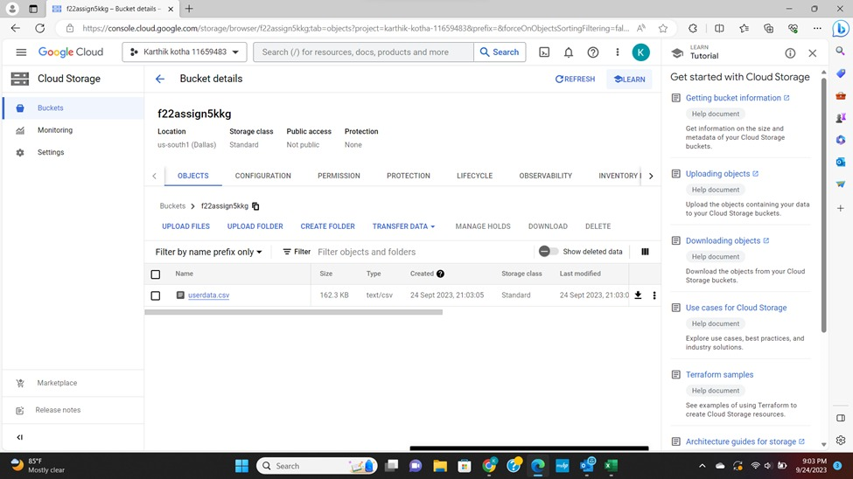

**References and Citations:**

Tung, L. (2022, July 4). *Cloud computing is about to hit another big milestone*. ZDNET. https://www.zdnet.com/article/cloud-computing-is-about-to-hit-another-big-milestone/

*Log In to Canvas*. (n.d.). https://unt.instructure.com/courses/96338/files/22556770?wrap=1